Pantry Food Guidelines
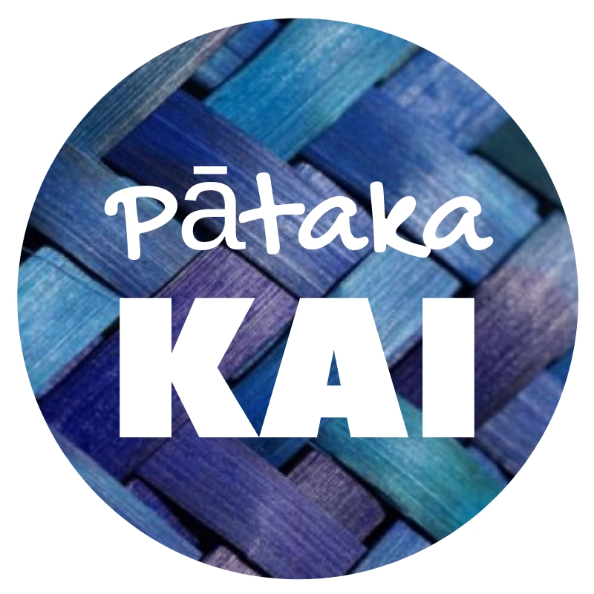

The following advice is aimed at educating anyone who periodically or regularly donates to any of our Pātaka Kai Open Street Pantries. Our pantries are setup up as a way to give residents and the surrounding community, the opportunity to share spare fruits, vegetables & any other excess food with each other.
Simply help yourself to anything in the pantry. It's free and you don't need to exchange anything to take anything out. Take what you need & leave what you can if you can.
When Donating Food:
- Food marked with a ‘Best-before’ date can be donated after the date has passed, provided it is otherwise fit to eat.
- Food withdrawn from sale because of incorrect/faulty labelling may be donated; however, correct information about the food needs to be identified and provided with the food so consumers can make informed choices.
- Packaging, or at least the inner wrapping, should completely enclose donated food. Do not donate any food that has been exposed and may have become contaminated.
- Food must be clear of mould or slime or other signs of spoilage, e.g. packaging inflated by spoilage gasses.
- Cans that are excessively rusty or have damaged seams, or ‘spring’ at the end, or are leaking should not be donated.
- We do not accept Fresh meat or any frozen food to our pantries.
- Cooked foods may be accepted with the exception that a kaitiaki has been informed first prior to donating. A decision will be made at the discretion of the kaitiaki of the pantry.
- If reusing boxes and packaging ensure that these have not been used for anything other than food, and have been made clean and hygienic.
- Keep food items separated from non-food items i.e. toiletries, animal food etc.

When Collecting Food:
- Please check that the food you are collecting is okay. We are not responsible if you get sick and can't monitor the pantry 24 hours a day so will often not see what goes in and out.
- Many rely on our pantries so please be considerate of others & only take what you need.
- Please be respectful of the pantry and leave it in tidy condition after you use it. This pantry belongs to all of us so we all need to look after it.

Additional information about food safety can be found on the MPI website at www.mpi.govt.nz.

If you have any specific food safety questions not covered by the available advice, or to report any concerns about any of our pantries please feel free to contact our Pātaka Kai team through our website www.patakai.co.nz.

